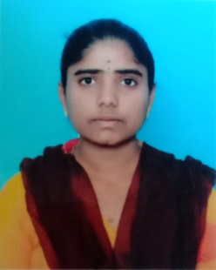 RESUME

S.Deepa

[deepa.selvam1212@gmail.com](mailto:deepa.selvam1212@gmail.com)

7550250301

CAREER OBJECTIVES

To pursue a job opportunity in a competitive environment that will challenge me to push my boundaries and expand my knowledge in the field of computer science while allowing me to add value to the dynamics of the company.

EDUCATION

|  |  |  |  |  |
| --- | --- | --- | --- | --- |
| DEGREE/COURSE | INSTITUTE | UNIVERSITY | PERCENTAGE | YEAR OF PASSING |
| B.Sc(CS) | Government Arts(Autonomous)College  Coimbatore-18 | Bharathiar  University  Coimbatore | 84  (up to 4 sem) | 2024 |
| HSC | Government Girls  Higher Secondary School,  Uthangarai | State Board | 88.5 | 2021 |
| SSLC | Government Girls  Higher Secondary School,  Uthangarai | State Board | 77.8 | 2019 |

CERTIFICATION COURSE

* Microsoft(Excel,Word,Powerpoint,Teams,Onedrive, Outlook,Sharepoint)
* Cyber Security Basics
* HTML , CSS , JAVASCRIPT

SKILLSETS

* Web Development
* Self-Motivated and Hardworking
* Positive thinker

|  |  |
| --- | --- |
| HOBBIES   * Reading boks * Travelling * Listening music * Playing games   PROGRAMMING DETAILS   * C program * Python * HTML , CSS , JAVASCRIPT   PERSONAL DETAILS  Father’s name :Mr.Selvaraj    Address : D.no 310,Kavthukarankottai  Kanjanur Village  Uthangarai Taluk  Krishnagiri-635304  Date of birth :02/06/2004  Gender :Female  Nationality :India  Language :Tamil,English  DECLARATION  I hereby declare that the above information is true to the best of my  Knowledge and belief.  Date :  Place : Signature |  |

|  |  |  |  |  |
| --- | --- | --- | --- | --- |
|  | | | | |
|  |  |  |  |  |